Worksheet 11.1

How observant are you?
Student: Class:
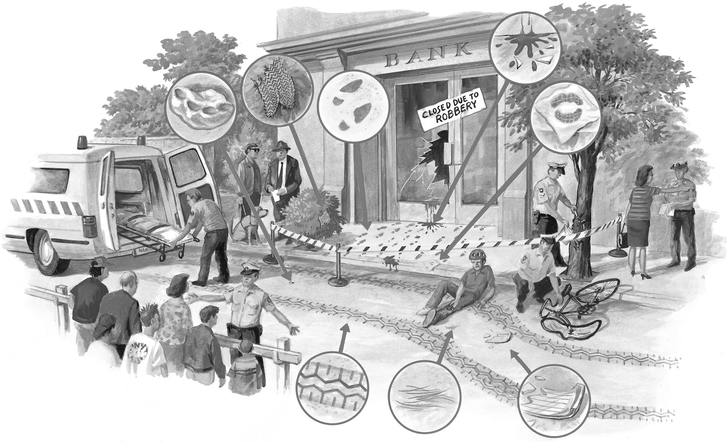
Examine the crime scene above.

1. List the evidence that you can observe in the diagram.

2. What other types of evidence could be taken?

3. Use the evidence you have observed to build up a story about what might have happened.

4. What conclusions can you make about the perpetrator(s)?

